PAUL K. FOX

Residence: 1564 Hastings Mill Road
Upper St. Clair, PA 15241-2860
Phone: (412) 596-7937
Email: paulkfox.usc@gmail.com
WWW: https://paulfox.blog/
LinkedIn: https://www.linkedin.com/in/paul-fox-7247a341/

Employment
Educator (Strings 5-12, Choral 9-12, Band 4, Theory 9-12), Upper St. Clair School District (1980-2013)
Performing Arts Curriculum Leader (Grades 1-12), Upper St. Clair School District (2006-2013)
Director/Producer 30 Spring Musicals, 5 Choral Musicals, 29 Fall Plays, Upper St. Clair High School (1983-2013)
Educator (General Music K-8, Choral 7-12), Edgewood School District (1978-1980)
Other Experience
Author/Blogger/Publisher of more than 200+ articles on educator care/health/wellness, creativity, ethics, interview strategies, marketing professionalism, music education pre- & in-service training, public relations, retirement resources, and technology for a variety of state and national publications and websites, most of which are archived at https://paulfox.blog/ (1980-present)
Clinician/Guest Speaker/Presenter of 80+ professional development workshops/webinars on teacher career development, ethics, interview strategies, leadership, retirement preparation, school musicals, teacher self-care, and technology for the Arts Education Collaborative, Colleges/Universities in PA, DC Music Educators Association, PDK International (Kappan), Pennsylvania Collegiate Music Educators Association, Pennsylvania Department of Education Intermediate Units 5 & 19, Pennsylvania Department of Education SAS Institute, Pennsylvania Music Educators Association, National Association for Music Education, State Education Agency Directors, Thomas W. Bailey PDE-Approved Act 45/48 Classes on Ethics, and Washington Music Educators Association (1981-present)
Founding Director of South Hills Junior Orchestra (1983-present)
Staff Announcer for the “Pride of Upper St. Clair” High School Marching Band (1986-present)
School District Representative/Steering Committee of UPPER ST CLAIR TODAY (1994-present)
Communications Director/Fine and Performing Arts Focus Chair of the Community Foundation of Upper St. Clair (1995-present)
State Coordinator/Retired Members Pennsylvania Music Educators Association (2013-present)
Volunteer Escort for the St. Clair Health (2013-present)
State Chair (2016-2024) and Member (2016-present) of the Pennsylvania Music Educators Association Council for Teacher Training, Recruitment, and Retention
Education
Bachelor of Fine Arts in Music, University Honors, Carnegie-Mellon University (1977)
Instructional Certification K-12 Music, Pennsylvania Department of Education (1978)
Master of Fine Arts in Music Education, Carnegie-Mellon University (1979)
Paul K. Fox – 2025-26 Calendar of Professional Engagements

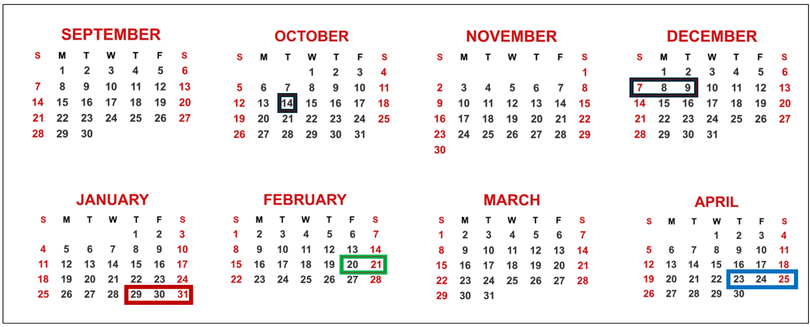

DATE | TIME | LOCATION | SUBJECT
October 14, 2025 | 4:30 p.m. | Washington & Jefferson College | Ethics
December 7-9 | All-day | PA Department of Education  SAS Institute – Hershey, PA | Care, Leadership
January 29-31, 2026 | All-day | DCMEA Winter Conference – Washington D.C. | Care, Ethics, Social Media
February 20-21 | All-day | MMEA Annual Conference – Baltimore Convention Center | Interviewing
April 23-25 | All-day | PMEA Annual Conference – Kalahari Resort/Poconos | Self-Care, Retirement 101, Boosters

Paul K. Fox – Sample Articles and Blogs

- Bookends – The Life Cycle of a Successful and Happy Educator https://paulfox.blog/2024/11/17/our-next-chapter/
- Creativity in Education – 3-Part Series https://paulfox.blog/creativity-in-education/
- The Fast Track to Exceptional Educator Ethics Training (series of blogs) https://paulfox.blog/category/ethics/
- Leadership 101 https://paulfox.blog/2024/07/23/growing-student-leaders/
- Preparing for Those Upcoming Employment Screenings https://paulfox.blog/2025/02/04/the-get-a-job-toolbox/
- Retirement Transitioning (series of blogs) https://paulfox.blog/category/retirement-resources/
- The Teacher’s Guide for Fostering Positive Relations… with School Administrators https://paulfox.blog/2019/03/19/the-care-and-feeding-of-your-principal/
- Ultimate Interview Primer https://paulfox.blog/wp-content/uploads/2025/01/ultimate-interview-clinic-super-packet.pdf
More about Paul K. Fox: https://paulfox.blog/about/

